**Celebrating 30 Years of Career Development International:   
A Structural Topic Model of Nine Topics Among 1,186 Abstracts (1996-2025)**

**Dr. Michael Healy 1, 2**

1 School of Education, University of Southern Queensland, Toowoomba, Australia

2 Education Services Australia, Melbourne, Australia

Email Address: michael.healy@unisq.edu.au ORCiD: 0000-0002-9572-2182

**Professor Yehuda Baruch 3**

3 Southampton Business School, University of Southampton, Hampshire, UK

Email Address: y.baruch@soton.ac.uk ORCiD: 0000-0002-0678-6273

**Professor Sébastien Point 4**

4 Strasbourg Business School, Université de Strasbourg, Strasbourg, France

Email Address: point@unistra.fr ORCiD: 0000-0002-4988-5300

**Associate Professor Jennifer A. Harrison 5**

5 EM Normandie Business School, Le Havre, France

Email Address: jharrison@em-normandie.fr ORCiD: 0000-0002-5414-1285

**Professor Beatrice I. J. M. Van der Heijden 6, 7, 8, 9, 10** [Corresponding Author]

6 Institute for Management Research, Radboud University, Nijmegen, Netherlands

7 Faculty of Management, Open Universiteit, Heerlen, Netherlands

8 Department of Marketing, Innovation and Organisation, Ghent University, Ghent, Belgium

9 University of the Free State Business School, Bloemfontein, South Africa

10 Kingston Business School, Kingston University, London, United Kingdom

Email Address: beatrice.vanderheijden@ru.nl ORCiD: 0000-0001-8672-5368

**Professor Jon Briscoe 11**

11 Northern Illinois University College of Business, Northern Illinois University, Illinois, US

Email Address: jonbriscoe@niu.edu ORCiD: 0000-0001-7044-0034

**Associate Professor William E. Donald 3, 12**

3 Southampton Business School, University of Southampton, Hampshire, UK

12 Donald Research & Consulting, Hampshire, UK

Email Address: w.e.donald@soton.ac.uk ORCiD: 0000-0002-3670-5374

**Celebrating 30 Years of Career Development International:   
A Structural Topic Model of Nine Topics Among 1,186 Abstracts (1996-2025)**

Abstract

**Purpose:** This study maps the conceptual structure of *Career Development International* (*CDI*) over its 30-year history. It identifies the principal topics based on published works between January 1996 and June 2025 and traces the shifting prevalence of these topics over time.

**Design/methodology/approach**: Structural topic modelling was applied to a dataset of 1,186 *CDI* abstracts. Model selection and interpretability checks supported a nine-topic solution that maximised thematic distinctiveness and coherence. The analysis tracks longitudinal variation in topic prevalence, profiles 18 influential authors and 12 high impact articles to distinguish specialist and generalist patterns of contribution, and links thematic clusters to citation impact. Interpretive depth was further enriched through reflections from seven scholars with strong connections to CDI.

**Findings**: The nine topics identified capture the journal’s evolving emphases and reveal both enduring interests and emerging priorities in the field. Temporal patterns highlight phases of growth and decline across topics, while author and article profiling distinguishes between concentrated expertise and broad engagement. Citation analysis demonstrates how particular topics have influenced scholarly impact. Insights from seven scholars contextualise these dynamics and suggest promising directions for future inquiry.

**Originality**: Extending earlier bibliometric work undertaken at CDI’s 25th anniversary, this study offers similar findings but with greater granularity and a multi-dimensional perspective that integrates computational text analysis with expert reflection. The findings provide an empirical foundation for current and future editors, broader editorial team members, and prospective contributors to understand the journal’s trajectory and to shape its future development.

**Keywords**: career development; expatriate careers; job insecurity; graduate employability; leadership; mentoring; structural topic modelling; sustainable development; talent management; wellbeing; work-family dynamics; work-identity.

**Article Classification**: Research Article

# Introduction

*Career Development International* (*CDI*) was first published in 1996 following the merger of *Executive Development* with the *International Journal of Career Management*. Over the past three decades *Emerald* has published the journal, guided by nine Editors: Jeff Gold (1996-1999), Alan Fish (1999-2001), Stephen Gibb (2002-2004), Yehuda Baruch (2004-2007), Hetty van Emmerik (2007-2010), Jim Jawahar (2007-2022), Jennifer A. Harrison (2023-2026), William E. Donald (2025-2028), and [Masked until formally announced] (2026-2029). Their reflections on the journal’s evolution appear in the specially commissioned editorial *Celebrating 30 Years of Career Development International* (Gold *et al.*, 2026).

At its inception, *CDI* was primarily a practitioner-oriented outlet focusing on how employers, managers and leaders manage their employees’ careers. Over time, it transitioned towards a more academic focus and paid greater attention to workers’ own agency, while retaining relevance to practitioners in a range of career-related professions. Since 2004, *CDI* has worked closely with the *Careers Division* of the *Academy of Management* to attract high-quality submissions and establish its role as a developmental journal. In 2024, the launch of the *Practitioner Insights* section (Harrison and Donald, 2024) reaffirmed *CDI*’s original practitioner-oriented focus while strengthening its commitment to also engaging academics and policymakers. Today, *CDI* is among the most interdisciplinary of career development journals, publishing across vocational and organisational psychology, human resource management, leadership, graduate employability, career counselling, labour studies, and related fields, as well as publishing articles which seek to integrate or reconcile the diffuse literatures among them (Akkermans, *et al*., 2024; Healy *et al*., 2025)

On the occasion of *CDI*’s 25th anniversary, Varma *et al.* (2021) published a bibliometric review. Five years later, the rationale for a new review is twofold. First, the external environment has shifted dramatically. Global disruptions such as the COVID-19 pandemic, the United Kingdom’s departure from the European Union, the rise of large language models and artificial intelligence, and geopolitical instability have reshaped career experiences as never before. In parallel, *CDI* has hosted special issues on timely and emergent topics, including career shocks (Akkermans *et al*., 2021), career theory and research trends (Jawahar, 2022), self-initiated expatriates (Andresen *et al.*, 2023), linguistic profiling (Hughes *et al*., 2024), positive psychology (Budworth and Masood, 2024), and neurodivergence (Donald *et al*., 2025). In addition, several highly cited theoretical contributions have advanced the field, such as calls to integrate graduate employability and work employability literatures (Akkermans *et al*., 2024), the reframing of sustainable careers (Donald *et al*., 2024a), and explorations of career trajectories in the future workplace (Rabenu and Baruch, 2025).

Second, while bibliometric analysis provides valuable insight into publication trends and social structures of scholarship, Structural Topic Modelling (STM) offers finer granularity and richer fidelity in illustrating the concepts that have been written about (Lindstedt, 2019; Roberts *et al*., 2019). STEM allows latent topic clusters to be uncovered and their trajectories traced over time. Building on Varma *et al*. (2021), the present study applies STM to 1,186 abstracts published in *CDI* between January 1996 and June 2025. The analysis identifies nine coherent thematic clusters, examines longitudinal variation in topic prevalence, profiles 18 influential authors and 12 highly cited articles to differentiate specialist from generalist contributions, and evaluates the citation impact of each theme. Additional interpretive depth is provided through reflections from seven scholars closely associated with *CDI*.

Consequently, this study extends the 25th anniversary review by offering a multi-dimensional perspective that combines computational text analysis and expert commentary. In doing so, it provides an empirical foundation for current and future editors, the editorial team, and contributors to understand *CDI*’s intellectual trajectory and to inform its future direction.

The manuscript is structured as follows. We first examine the intellectual, social, and conceptual structure of *CDI* and its suitability for structural topic modelling. We then present our methodological approach and results, highlighting the nine-topic solution. Finally, we discuss these findings in comparison with the 25th anniversary review and draw on the reflections of seven CDI scholars to identify promising avenues for future research.

## Intellectual, Social, and Conceptual Structure of CDI

Different approaches to science mapping can illustrate the characteristics of and structures within a body of literature (Cuccurullo and Aria, 2022; Zupic and Čater, 2015). Citation-based analyses reveal the *intellectual structure* of a field, highlighting foundational works and tracing the influence of ideas through citation networks. Co-authorship, institutional affiliations, and country collaboration networks reveal the *social structure* of a field, highlighting how scholars connect and collaborate. Key word co-occurrence, bibliographic coupling, and topic modelling reveal the *conceptual structure* of a field, highlighting themes, topics, and patterns of research content.

Recently, Varma *et al.* (2021) conducted a bibliometric review of 25 years of articles published in *CDI*, investigating the social, intellectual, and conceptual structure of the journal. With regard to the social structure of the journal, they illustrated strong international collaboration and noted a marked increase in the number of authors contributing to published articles. They highlighted elements of the intellectual structure, such as the most cited authors and articles, as well as analysing how various factors influence citation impact. To explore the conceptual structure, they illustrated five clusters of related articles—career development, work engagement, entrepreneurship career, career outcomes, and career mentoring—from a bibliographic coupling analysis, which is based on the assumption that articles on a similar topic will cite common references and, in turn, be cited together by subsequent articles. They also used author keywords to trace trending topics over time.

However, the methods used to explore the conceptual structure in Varma *et al.* (2021) are quite limited. Bibliographic coupling only captures surface-level relationships based on shared citations, potentially missing related papers that use different theoretical frameworks or cite different foundational works. Additionally, citations signal more than just topical relevance—including author relationships, citation trading, strategic positioning, and disciplinary signalling—meaning that shared reference patterns may reflect academic politics or citation conventions rather than genuine conceptual similarity. Bibliographic coupling also operates at a coarse level of granularity, treating entire documents as a single conceptual unit and producing lower fidelity analyses of nuanced conceptual structures. Author keywords offer much smaller datasets for analysis—a half dozen words per article—and can be undermined by redundancy, with the most common keyword in Varma *et al.* (2021) being “career development”.

## Structural Topic Model (STM) of CDI

In this article, we seek to explore the conceptual structure of *CDI* in greater depth and with greater nuance than afforded by keyword or bibliographic coupling. To do so, we apply the method Structural Topic Modelling (STM: Lindstedt, 2019; Roberts *et al*., 2019) to the abstracts of all articles published in CDI over its 30-year history. STM is an unsupervised statistical method that analyses patterns of word co-occurrence within large document collections. Clusters of co-occurring words represent latent topics which distinguish the texts in that topic from those in others. Researchers are therefore able to map the conceptual structure of academic fields without bias from prior assumptions about topic boundaries or disciplinary classifications (Lindstedt, 2019; Roberts *et al*., 2019). Rather than assigning each text entirely to a given topic, STM allows texts to exhibit mixed membership across multiple topics—each text is a blend of articles and each text is a blend of topics—which provides nuanced insights into often closely related conceptual themes. Further, STM enables the use of other metadata variables, such as author names, affiliations, and year of publication, to explore more complex correlations and enable deeper comparison between topics. A recent STM study mapping employability research, published in *CDI*, demonstrated the fidelity, validity, and value of the method for the complex and diffuse field of career development (Healy *et al*., 2025).

# Method

## Data Collection and Preparation

This retrospective analysis examined the complete corpus of articles published in CDI from its first issue in 1996 through to June 2025. Full bibliographic records, including abstracts, for all articles were retrieved from the Scopus database, with editorials and book reviews excluded, yielding 1,186 articles.

The primary data field for this STM analysis is the abstract, as it represents a detailed description of the content of each article. Abstracts were processed to enable precise analysis and reduce noise. Punctuation, numbers, standard English stopwords, common research article terminology (e.g., “study,” “research,” “findings”), and copyright statements were removed to focus the analysis on articles’ substantive content. Finally, the abstracts were lemmatised, converting plural and conjugate forms of words to their base form (e.g., managed, managing, and manages were all converted to manage), reducing noise from different grammatical variations of the same word.

## Data Analysis

### Topic number selection

STM does not itself identify any empirically definitive number of topics in a corpus. It will generate exactly as many topics as requested by the researcher, but whether those topics represent meaningful, distinct, and coherent themes depends entirely on evaluation and interpretation by the researcher (Lindstedt, 2019; Roberts *et al*., 2019). The first step toward STM is to decide how many topics to model, which is done by first evaluating a range of candidate models and then iteratively narrowing them down to the one that is most meaningful (Lindstedt, 2019; Roberts *et al.*, 2019).

First, candidate models were generated, ranging from 3 to 30 topics, in increments of three. These models were evaluated using quantitative measures of semantic coherence and exclusivity. Semantic coherence measures the probability that high-frequency words within topics co-occur in the same documents, while exclusivity assesses the degree to which words are distinctive to individual topics rather than shared across multiple themes (Roberts *et al*., 2019). The range between 6 and 15 topics showed the best balance between semantic coherence and exclusivity.

A subsequent exploratory modelling of 6 to 15 topics, in increments of one, suggested that 9, 10, or 11 topics represented the best balance of semantic coherence and exclusivity. Manual qualitative inspection of the topic keywords and representative documents for these three models ultimately supported the 9-topic solution as offering the highest number of qualitatively meaningful and distinct topics, representing a comprehensive yet parsimonious representation of scholarship across the CDI’s three-decade publication record.

### Naming, describing, and validating the topics

Just as STM does not identify how many topics there are in a corpus, it does not describe what the topics mean, or indeed if they mean anything at all. That remains the job of the researcher, based on their knowledge of the data and the context of the research (Lindstedt, 2019; Roberts *et al*., 2019). Once the 9-topic model was chosen, the keywords for each topic (see Table I) were studied and a qualitative summary was written for each. The summaries reflect the conceptual themes that are proportionally most aligned with each topic.

INSERT TABLE I HERE

STM provides the researcher with a matrix which includes, for each article, the proportion of words from the abstract that align with the words assigned to each topic. So, an article that deals exclusively with one topic would have a value of 1 for that topic and zero for all others, while an article that is perfectly evenly balanced across topics would show a value of approximately 0.111 for each. Similarly, the overall topic proportions for individual authors can be calculated from their individual articles, resulting in a kind of “conceptual fingerprint” (Healy *et al*., 2025, p. 228), as visualised in the results section of this study.

These visualisations provide the best method of validating the integrity and value of the topic model. Based on prior knowledge of an article’s content or an author’s oeuvre, the researcher may predict the topic proportions they expect to be illustrated in the visualisation. Aberrant results can then be investigated to refine how the topics are understood and described, identify errors in data collection or processing, or, in extreme cases, question the validity of the model.

# Results

## Nine Topics in 30 years of *Career Development International*

Our STM of 1186 articles published in *CDI* from January 1996 to June 2025 illustrates nine distinct topics in the research, as named and described below. The names and descriptions were not computationally created by the STM itself; they are qualitative interpretations of the topics by the authors. The keywords for each topic, which informed the names and summaries below, are presented in Table I.

### Topic 1: Sustainable, protean, boundaryless, and women's careers

This topic explores the career experiences of women across cultural and professional settings with a focus on sustainable career development. It investigates barriers such as gender norms, motherhood, and migration, alongside strategies women use to build authentic and adaptable careers. Concepts like protean and boundaryless careers help explain women’s self-directed career paths. Research includes studies of entrepreneurs, academics, and professionals in diverse regions. The role of identity, social capital, and language is examined. This area supports efforts to promote gender equality and develop policies that enable women’s long-term career success and fulfilment.

### Topic 2: Job insecurity, engagement, and proactive behaviours

This topic examines how individuals experience job insecurity and actively respond to protect and advance their careers. It highlights how employees take initiative by helping colleagues, voicing ideas, and managing how they are perceived to maintain or improve performance during uncertain times. Personal traits such as resilience and adaptability combine with organisational support to shape these behaviours. The quality of leader relationships influences trust and engagement, which affects career stability. Understanding these dynamics offers insight into how individuals navigate uncertainty and proactively manage their career development despite challenging work environments.

### Topic 3: Work-family dynamics and well-being

This topic examines how individuals balance work and family roles and the impact on their well-being and career outcomes. It explores how conflicts between work and family can lead to burnout, emotional exhaustion, and decreased motivation, while positive interactions can enhance satisfaction and engagement. Personal factors like age, support from supervisors, and mindfulness influence these experiences. The effects often extend beyond the individual to their family life. Understanding these dynamics helps individuals and organisations create strategies to manage work-life balance, reduce stress, and support long-term career success and personal well-being.

### Topic 4: Recruitment and talent management

This topic explores how individuals experience recruitment and talent development in diverse and evolving labour markets. It examines how people engage with organisational processes, decision-making, and training programmes designed to support their integration and development. Additionally, it focuses on the challenges faced by diverse groups such as veterans, displaced workers, and employees in Small and Medium Enterprises as they navigate hiring and career growth opportunities. It also considers how individuals balance immediate job demands with long-term career goals. Insights help individuals understand and adapt to recruitment practices that promote inclusion, skill-building, and career advancement.

### Topic 5: Leadership and career change

This topic explores how individuals, especially leaders and professionals, navigate career transitions and adapt to organisational change. It focuses on personal development through executive coaching, targeted assessments, and leadership programmes that prepare them for new roles and challenges. The impact of unexpected career shocks and the need for proactive change management are highlighted. Ethical leadership and cultural awareness play important roles in these processes. By understanding these experiences, individuals can build resilience and effectively manage their career growth while contributing to organisational success in dynamic environments.

### Topic 6: Graduate employability, job search and career choice

This topic explores how graduates navigate the critical transition from education to the workforce. It looks at how personal factors like academic achievement, extracurricular involvement, personality traits, and generational influences shape their employability and job search strategies. Communication skills and entrepreneurial intentions are important for career success across diverse fields. The role of socio-cultural and educational experiences in shaping career aspirations is also examined. This research provides valuable insights to help graduates build confidence, make informed career choices, and develop skills needed for sustainable, fulfilling careers.

### Topic 7: Mentoring, relationships, and career development

This topic examines how individuals use mentoring relationships to support their career growth, learning, and professional identity development. It explores both formal and informal mentoring, focusing on the roles of mentors and protégés in providing guidance, emotional support, and skill development opportunities. The quality of these relationships influences career progression and personal growth. Challenges like maintaining commitment and managing potential conflicts are also addressed. Additionally, mentoring benefits mentors through expanded networks and self-improvement. Understanding these dynamics helps individuals maximise mentoring opportunities to advance their careers and strengthen their professional skills.

### Topic 8: Expatriate careers and international adjustment

This topic explores the personal and professional experiences of expatriates and self-initiated expatriates on international assignments. It examines how individuals culturally adjust, find job satisfaction, and develop their careers while working abroad. The role of organisational support, training, and networking in aiding successful transitions is highlighted. Special attention is given to challenges faced by female expatriates and the importance of diversity and inclusion. Understanding these factors helps individuals navigate global mobility, build cultural competence, and shape their career paths. Insights inform policies to enhance expatriate success and career growth through international opportunities.

### Topic 9: Work identity and temporary or precarious employment

This topic explores how individuals develop and maintain their professional identity while navigating temporary or insecure employment. It focuses on the personal challenges faced by those with short-term contracts or unstable jobs and how these affect their self-concept and career growth. It considers how work-life balance, organisational connection, and social status influence identity during employment uncertainty. The topic also highlights the experiences of refugees and migrants whose careers are affected by wider social and political contexts. Understanding these perspectives helps individuals manage identity and career development despite precarious work conditions.

## Topic Trends: 1996-2025

Figure 1 illustrates trends in the proportion of each topic by year of publication. As is clearly visible, *CDI*’s initial focus was on the management of other people’s careers by managers and leaders, with leadership and career change (topic 5) and recruitment and talent management (topic 4) being the most studied topics for the first seven years. However, this focus receded over the first five years of the journal, to be overtaken in the early 2000s by scholarship focused more on workers’ or students’ characteristics, needs, dynamics, and agency, such as sustainable, protean, boundaryless and women’s careers (topic 1), work-family dynamics and wellbeing (topic 3), graduate employability, job search and career choice (topic 6), and job insecurity (topic 2). In 2025, the most studied topics, sustainable career development (topic 1) and job insecurity (topic 2), share a central concern for equity, agency, and empowerment in career development.

INSERT FIGURE 1 HERE

## Topics by Author

Figure 2 illustrates the topic proportions of a selection of 18 authors who have contributed the most articles to *CDI*, whose work in *CDI* has been the most highly cited, and/or who appear as authors on this paper and have published in the journal. This figure is based only on the articles for which these authors appear first in the list of authors, to reflect their particular research interests more specifically. The conceptual fingerprint offered by the STM clearly shows the scholarly interests of each author, as well as identifying which have broader interests (e.g., Akkermans, Baruch, Donald) and which are more specialised (e.g., Arthur, Jawahar, Scheufeli).

INSERT FIGURE 2 HERE

## Topics by Article

Figure 3 illustrates topic proportions of a selection of 12 highly cited articles. The visualisations illustrate the latent topics of each article, which sometimes reflect a focus that is not intuitively aligned with the article's title or keywords, based as it is only on the language used in the abstracts. For example, Schaufeli *et al*.’s (2009) review of burnout research is labelled as work identity and temporary or precarious work, rather than work-life balance and wellbeing, because it is more a conceptual, phenomenological, and socio-cultural review than it is an account of the causes and outcomes of burnout.

INSERT FIGURE 3 HERE

## Topic Prevalence and Citation Impact

Figure 4 illustrates the relationship between topic prevalence and average citation impact, with the bubble size indicating the number of articles where each topic is prominent (>10% topic proportion). The figure illustrates that the most frequently studied topics are not necessarily the most highly cited. The most impactful topics, in terms of average citations, are job insecurity, engagement, and proactive behaviours (topic 3), and work identity and temporary and precious work (topic 2), the latter of which is the smallest topic in the dataset. The variables in Figure 4, citations and volume of publications per topic, are both lag indicators and therefore should be interpreted in concert with Figure 1, which shows how topic proportions have changed over time.

INSERT FIGURE 4 HERE

# Discussion

Our findings regarding the conceptual structure of *CDI* align broadly with those of Varma *et al.* (2021), but with greater granularity and fidelity enabled by the STM analysis. To write – similarities and differences.

**Author Reflections**

The seven authors of this manuscript have had significant involvement with *CDI* in various ways, often over many years. To draw on such experience, each author now offers a 250-word reflection covering (1) their involvement with *CDI* over the years, (2) their reflections on the findings presented in this manuscript, and (3) research avenues they would like to see further explored at *CDI* in the years ahead.

***Michael Healy***

To write

***Yehuda Baruch***

To write

***Sébastien Point***

To write

***Jennifer A. Harrison***

To write

***Beatrice I. J. M. Van der Heijden***

To write

***Jon Briscoe***

To write

***William E. Donald***

As Co-Editor-in-Chief of *CDI* and a long-time contributor since my doctoral studies, I view the STM findings with both scholarly interest and editorial purpose. The nine-topic model affirms *CDI*’s broad-church identity, capturing a balance between specialist and generalist contributions. Clear shifts emerge: recruitment and talent management have declined, while sustainable careers, job insecurity, work–family dynamics, and wellbeing have grown in prominence, reflecting evolving labour market conditions and scholarly priorities (Figure 1). Figure 2 highlights *CDI*’s role as a trusted outlet for leading scholars, reinforcing its intellectual reach and ongoing partnership with the *Academy of Management’s Careers Division*. Citation trends require careful interpretation. Figure 3 illustrates citation lag, where older contributions dominate, while Figure 4 shows that contemporary themes linked to social and technological disruption now attract greater attention than traditional HR topics.

Looking forward, these insights should inform editorial strategy. *CDI* is well placed to advance scholarship on marginalised groups across the life span and to encourage more submissions from underrepresented regions, including Africa, Asia, and South America. Further empirical engagement with sustainable career ecosystem theory (Donald, 2023; Donald et al., 2024b) is also needed, particularly examining artificial intelligence as a structural and disruptive force in careers. At the same time, strengthening the bridge to practice remains essential. Practitioner Insights, introduced in 2024, provides a platform to ensure the journal continues to serve academics, practitioners, and policymakers (Harrison and Donald, 2024). Together, these directions will deepen CDI’s interdisciplinarity and enhance its impact.

# Conclusion

This review of *CDI* at its 30-year milestone demonstrates how the journal has evolved into a leading interdisciplinary outlet for career scholarship. By applying STM to nearly three decades of abstracts, the study highlights both the continuity of core concerns and the emergence of new priorities that reflect changing societal and organisational contexts. Patterns of topic prevalence reveal the shifting contours of the field, while author profiling underscores the journal’s ability to accommodate both specialist and generalist expertise. The integration of citation analysis and reflections from experienced scholars further deepens understanding of the journal’s intellectual trajectory and future opportunities. Taken together, the findings show *CDI*’s responsiveness to global disruptions and evolving debates in careers research. They also provide a foundation for guiding editorial strategy, encouraging contributions from diverse voices, and shaping future research agendas in career development.

# References

Akkermans, J., Donald, W.E., Jackson, D. and Forrier, A. (2024), “Are we talking about the same thing? The case for stronger connections between graduate and worker employability research”, *Career Development International*, Vol. 29 No. 1, pp. 80-92. doi: 10.1108/CDI-08-2023-0278.

Akkermans, R., Rodrigues, R., Mol, S.T., Seibert, S.E., and Khapova, S.N. (2021), “The role of career shocks in contemporary career development: key challenges and ways forward”, *Career Development International*, Vol. 26 No. 4, pp. 453–466.   
doi: 10.1108/CDI-07-2021-0172.

Andresen, M., Suutari, V., Muhr, S.L., Barzantny, C. and Dickmann, M. (2023), “Guest editorial: Careers of self-initiated expatriates: exploring the impact of context”, *Career Development International*, Vol. 28 No. 4, pp. 333–347. doi: 10.1108/CDI-08-2023-338.

Budworth, M-H. and Masood, H. (2024), “Guest editorial: Positive careers research: Where do we go from here?”, *Career Development International*, Vol. 29 No. 6, pp. 613-621.   
doi: 10.1108/CDI-11-2024-457

Cuccurullo, C. and Aria, M. (2022), *Science Mapping Analysis with Bibliometrix R-package: An Example*. In *bibliometrix.org*.

Donald, W.E., Cook, E.J. and Nimmi, P.M. (2025), “Fostering an inclusive and sustainable career ecosystem: Empowering neurodivergent individuals and employees to thrive”, *Career Development International*, Vol. 30, No. 7. doi: 10.1108/CDI-09-2025-0490.

Donald, W.E., Van der Heijden, B.I.J.M. and Manville, G. (2024), “(Re)Framing sustainable careers: Towards a conceptual model and future research agenda”, *Career Development International*, Vol. 29 No. 5, pp. 513-526. doi: 10.1108/CDI-02-2024-0073.

Gold, J., Fish, A., Gibb, S., Baruch, Y., van Emmerik, H., Jawahar, J., Harrison, J.A., Donald, W.E. and Manroop, L. (2026), “Editorial: Celebrating 30 Years of Career Development International”, *Career Development International*, Vol. 31. No. 1. This Issue.

Harrison, J.A. and Donald, W.E. (2024), “Editorial: Introducing the new practitioner insights section at Career Development International”, *Career Development International*,   
Vol. 29 No. 4, pp. 413-414. doi: 10.1108/CDI-08-2024-360.

Healy, M., McIlveen, P., Brown, J.L., Van Der Heijden, B.I.J.M. and Donald, W.E. (2025), “Eleven topics among 7,591 employability research abstracts (1942-2024): A structural topic model and call for interdisciplinary perspectives”, *Career Development International*, Vol. 30 No. 2, pp. 221–236. doi: 10.1108/CDI-09-2024-0383.

Hughes, C., Niu, Y. and Bowers, L. (2024), “Linguistic profiling and implications for career development”, *Career Development International*, Vol. 29 No. 3, pp. 289-296.   
doi: 10.1108/CDI-06-2024-359.

Jawahar, I.M. (2022), Guest editorial: Introducing the Special Issue on current trends in careers theory and research. *Career Development International*, Vol. 27 No. 1, pp. 1–4.   
doi: 10.1108/CDI-02-2022-335.

Lindstedt, N.C. (2019), “Structural topic modeling for social scientists: A brief case study with social movement studies literature, 2005–2017”, *Social Currents*, Vol. 6 No. 4,   
pp. 307–318. doi: 10.1177/2329496519846505.

Rabenu, E. and Baruch, Y. (2025), “The shape of careers in the future workplace: Extreme scenarios and their prospect impact”, *Career Development International*, Vol. 30 No. 1, pp. 3-27. doi: 10.1108/CDI-10-2023-0376.

Roberts, M.E., Stewart, B.M. and Tingley, D. (2019), “STM: An R package for structural topic models”, *Journal of Statistical Software*, Vol. 91 No. 2. doi: 10.18637/jss.v091.i02.

Varma, A., Kumar, S., Sureka, R. and Lim, W.M. (2021), “What do we know about career and development? Insights from Career Development International at age 25”, *Career Development International*, Vol. 27 No. 1, pp. 113–134.   
doi: 10.1108/CDI-08-2021-0210.

Zupic, I. and Čater, T. (2015), “Bibliometric methods in management and organization”, *Organizational Research Methods*, Vol. 18 No. 3, pp. 429–472.   
doi: 10.1177/1094428114562629.

# Table I: Topic Keywords

| **Topic** | **Highest Probability Words** | **Frequent and Exclusive Words** |
| --- | --- | --- |
| 1. Sustainable, protean, boundaryless, and women's careers | career, women, success, development, individual, work, protean, transition, interviews, practical | saudi, boundaryless, protean, career, migrant, transition, women, careers, advancement, arabia |
| 2. Job insecurity, engagement, and proactive behaviours | job, employees, relationship, performance, engagement, effect, work, employee, proactive, insecurity | insecurity, lmx, proactive, engagement, craft, crafting, mediating, psycap, mediate, mediation |
| 3. Work-family dynamics and well-being | work, employees, family, worker, satisfaction, job, relate, relationship, turnover, support | wfc, older, prevention, turnover, presenteeism, retirement, exhaustion, mindfulness, family, wfe |
| 4. Recruitment and talent management | management, manager, development, organisation, process, decision, recruitment, experience, resource, employer | military, crisis, veteran, civilian, ocm, smes, recruitment, recruiter, scheme, candidate |
| 5. Leadership and career change | change, development, organization, leadership, organizational, manager, career, management, business, leader | csr, shock, change, shocks, client, executive, coaching, assessment, programme, corporate |
| 6. Graduate employability, job search, and career choice | student, job, search, career, difference, graduate, university, mba, perceived, business | profiling, seeker, search, student, mba, generational, school, communication, choice, seekers |
| 7. Mentoring, relationships, and career development | mentoring, relationship, mentor, theory, development, developmental, career, support, network, mentors | mentoring, mentor, protégé, protégés, supervision, mentors, developmental, network, scs, functions |
| 8. Expatriate careers and international adjustment | expatriate, international, cultural, career, manager, country, adjustment, development, sie, literature | expatriate, sie, expatriation, repatriation, abroad, sies, overseas, international, assignment, repatriate |
| 9. Work identity and temporary or precarious employment | work, identity, employment, worker, temporary, professional, role, context, socialization, status | tactics, newcomer, temporary, socialization, wlb, unemployment, identity, historical, labour, contingent |

Source: Authors’ own creation.

# Figure 1

**Figure 2**

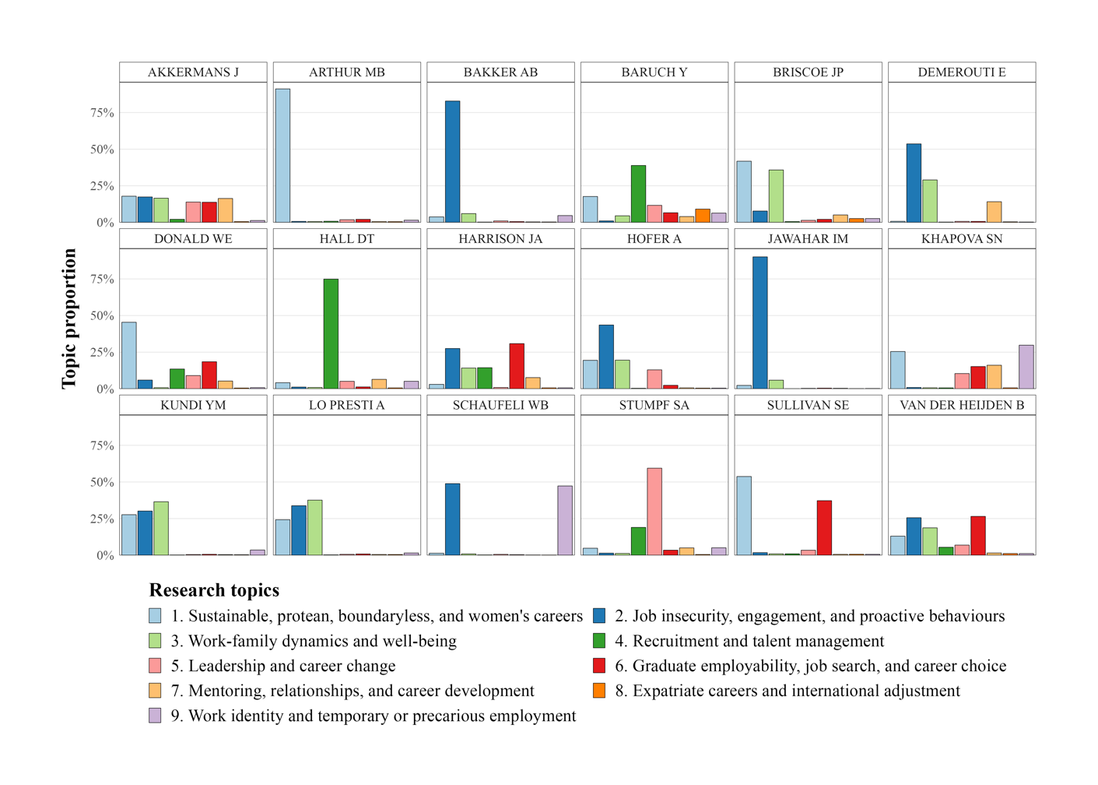

**Figure 3**

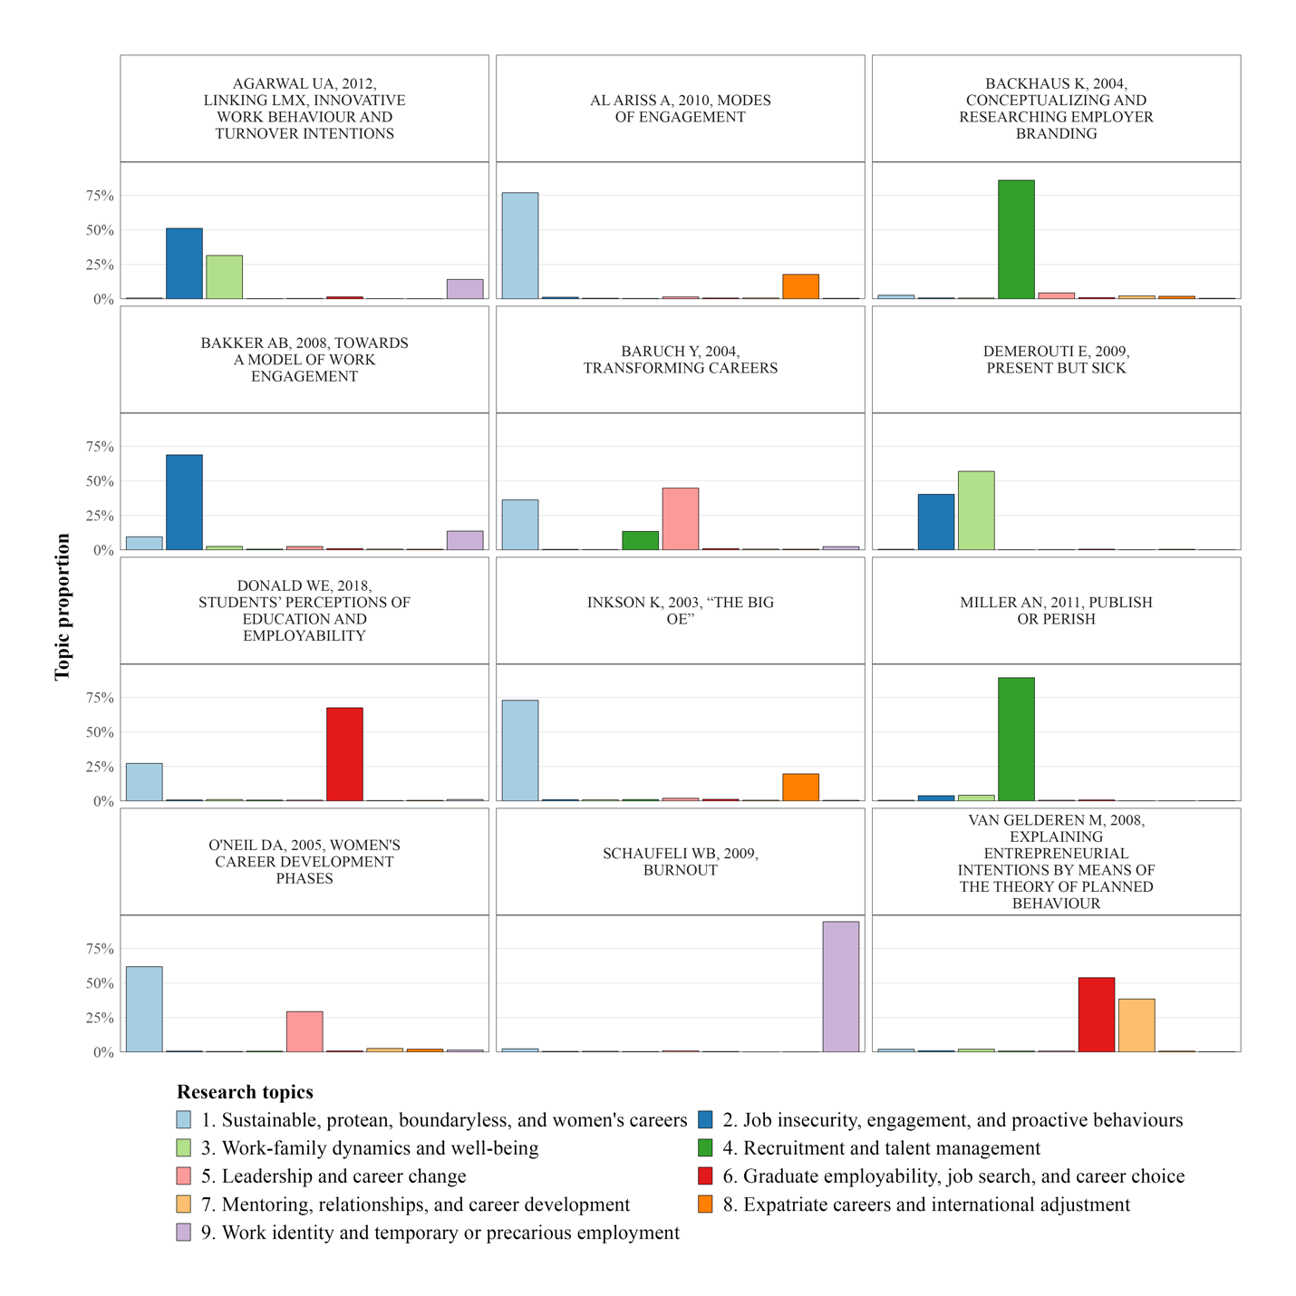

**Figure 4**

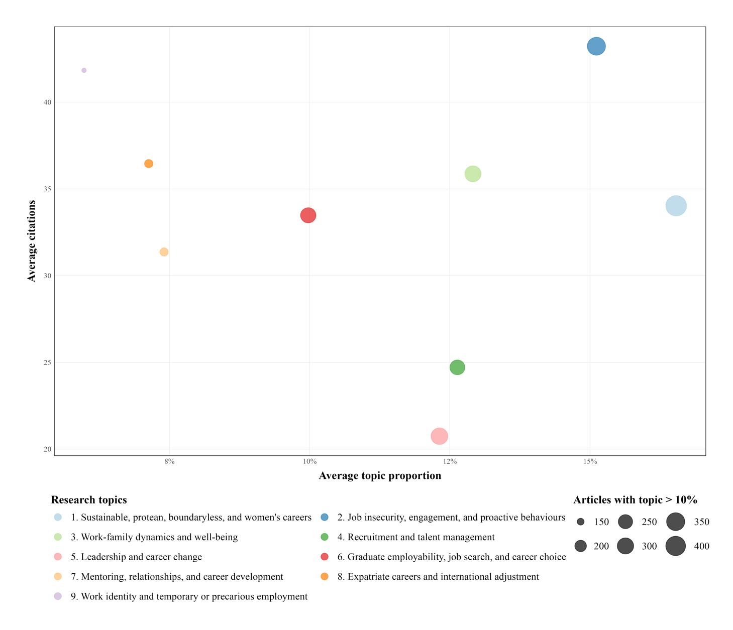

**Figure Captions**

Figure 1. Topic proportions by year of publication. Source: Authors’ own creation.

Figure 2. Topic proportions by author. Source: Authors’ own creation. Note: Topic proportions derived from first author articles only.

Figure 3. Topic proportions by article. Source: Authors’ own creation.

Figure 4. Citation impact of topics. Source: Authors’ own creation.